Creating Range

We will be creating a new range event

Minor
Cluster it

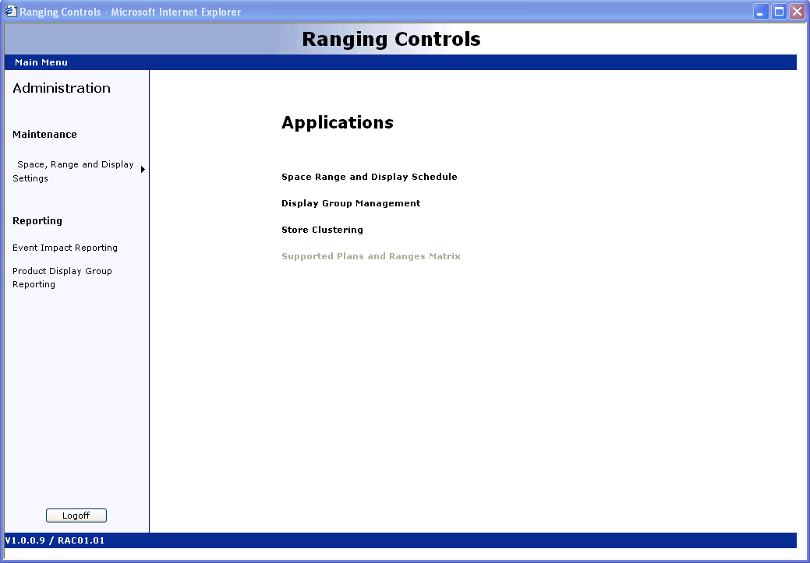

Click Space, Range and Display Schedule

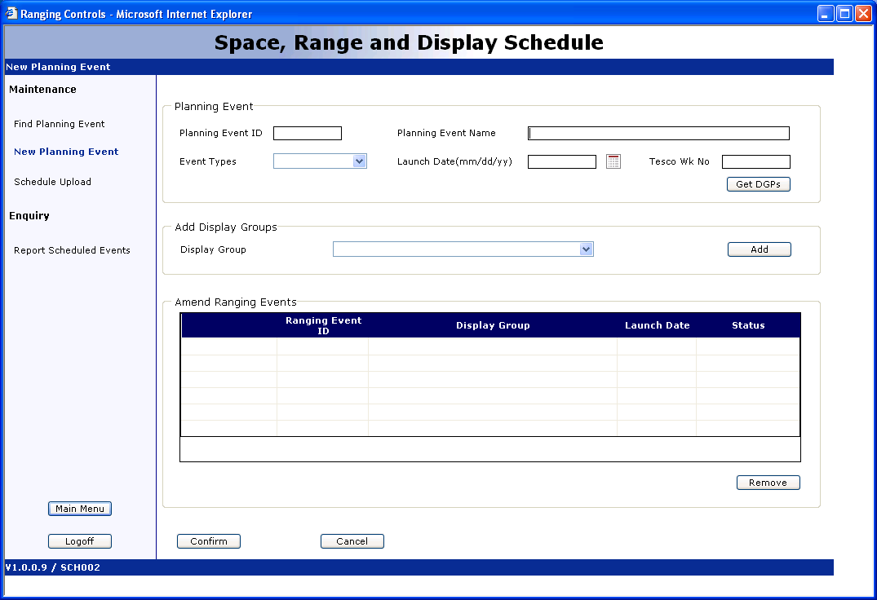

Click New Planning Event link on upper left

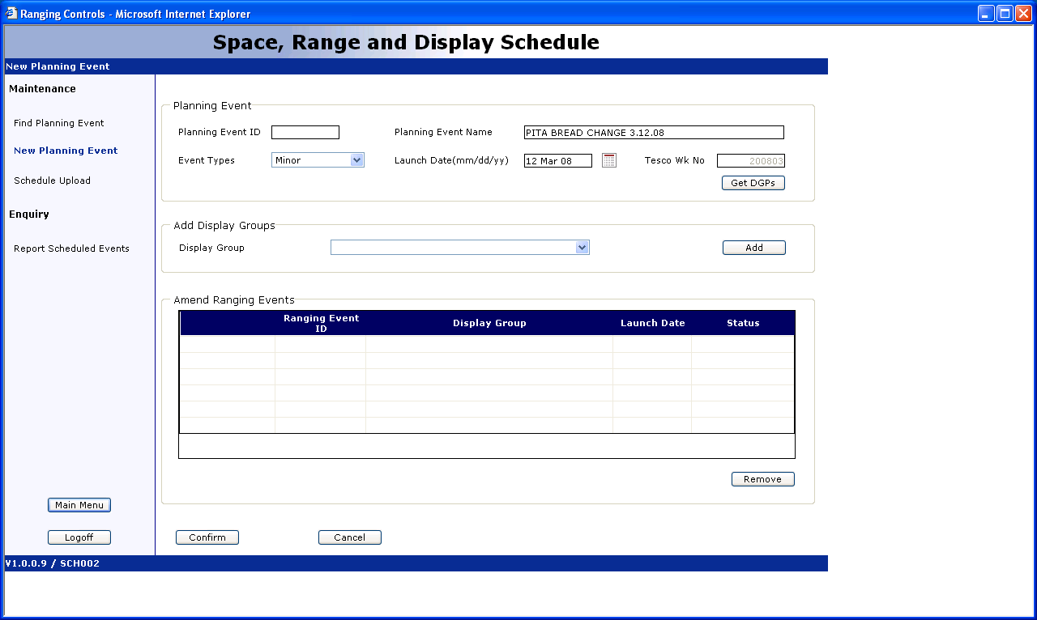

Planning Event Name field enter: Pita Bread Change 3.12.08 (description and date to easily identify the PE you’ve created)

Event Type: Minor

Launch Date: 12 March 08 (Live Date – Live date of Planogram)

Click on DGP – Display Group: 200803

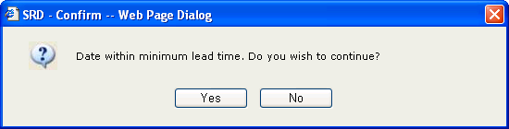

Click Yes

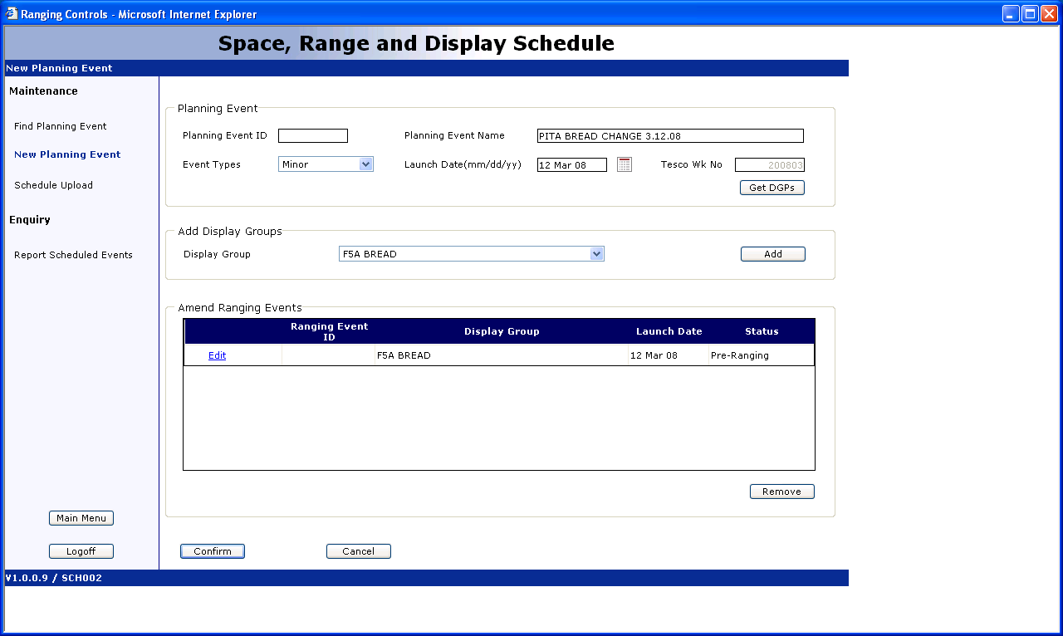

Click Add Display Group drop down window:

F5A Bread and click ADD

Click Confirm

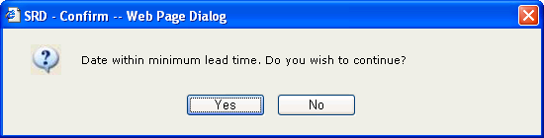

Click Yes

Click COnfirm

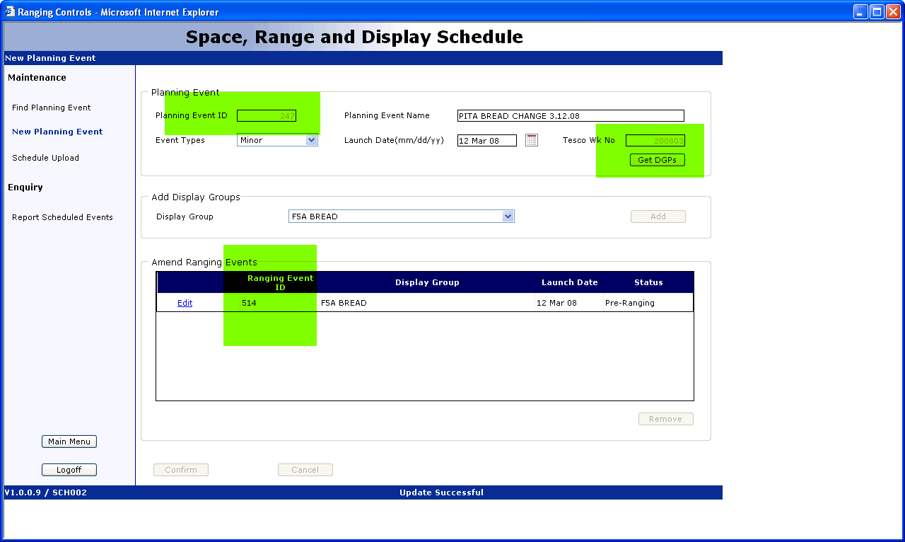

3 thingsthat the event has been created:

Planning Event ID: 247
Tesco Week No: 200803
Ranging Event ID: 514

Go back to main menu by clicking Main Menu link on left frame

Click on Store Clustering

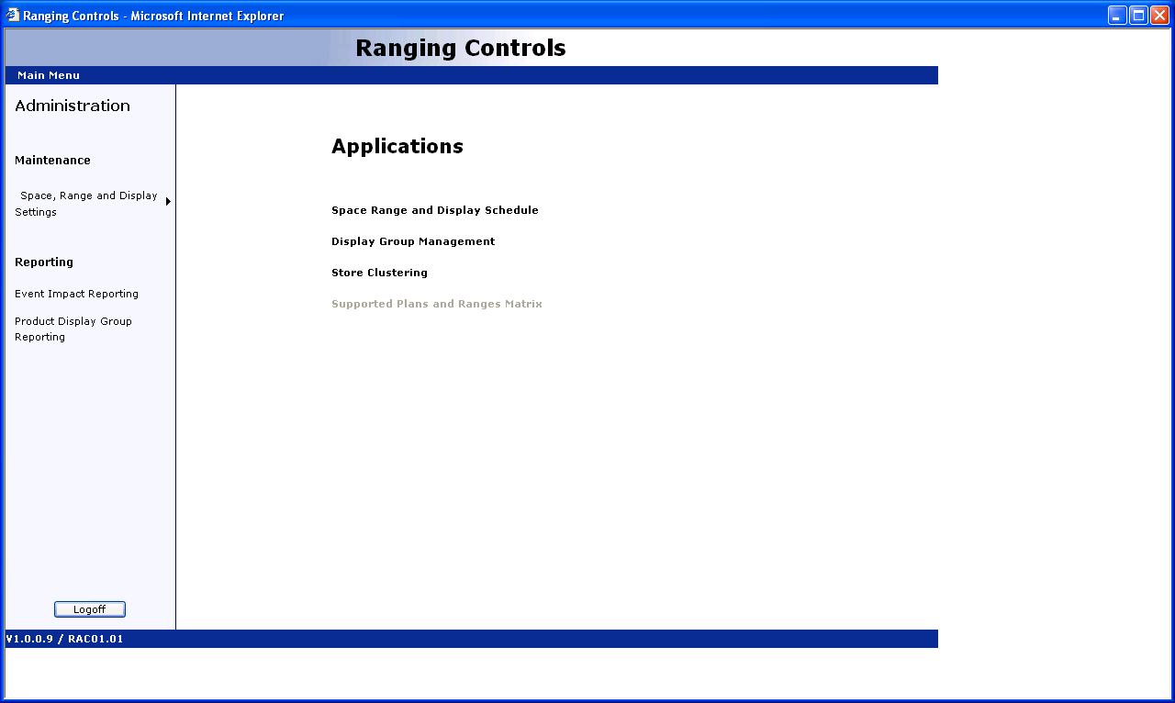

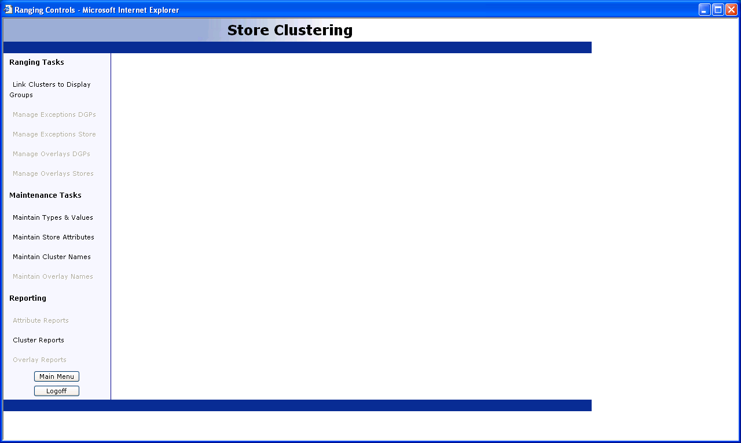

Click Link Clusters to Display Group

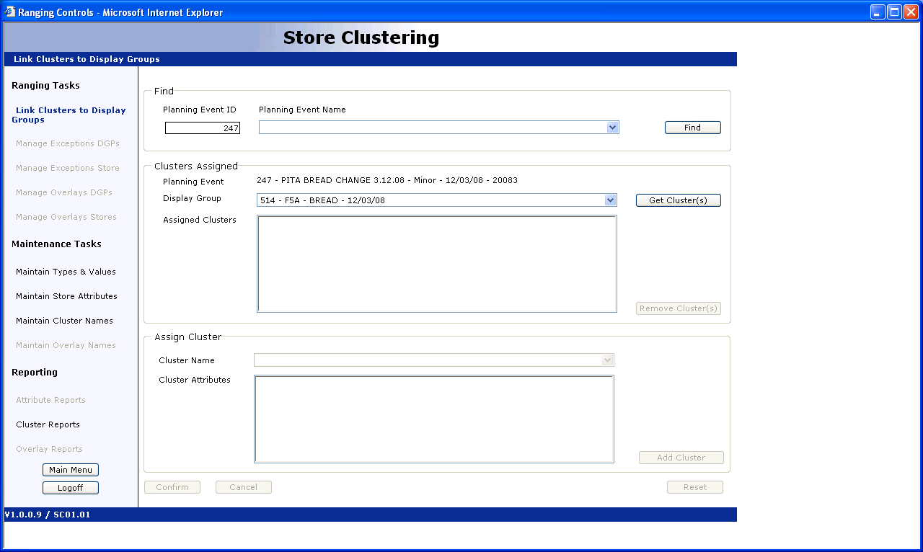

Enter the Planning Event ID: 247
Click on Find
Then click on “Get Clusters”

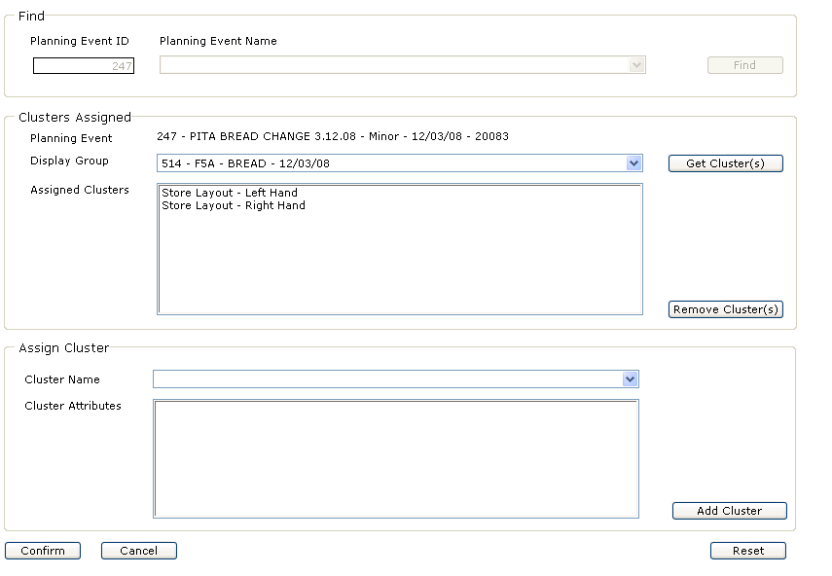

Clusters will appear (Left Hand and Right hand)

Then click “Confirm”

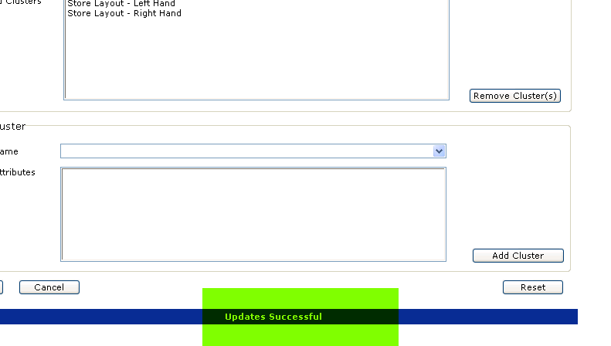

After you click Confirm “Updates Successful” will validate your work.

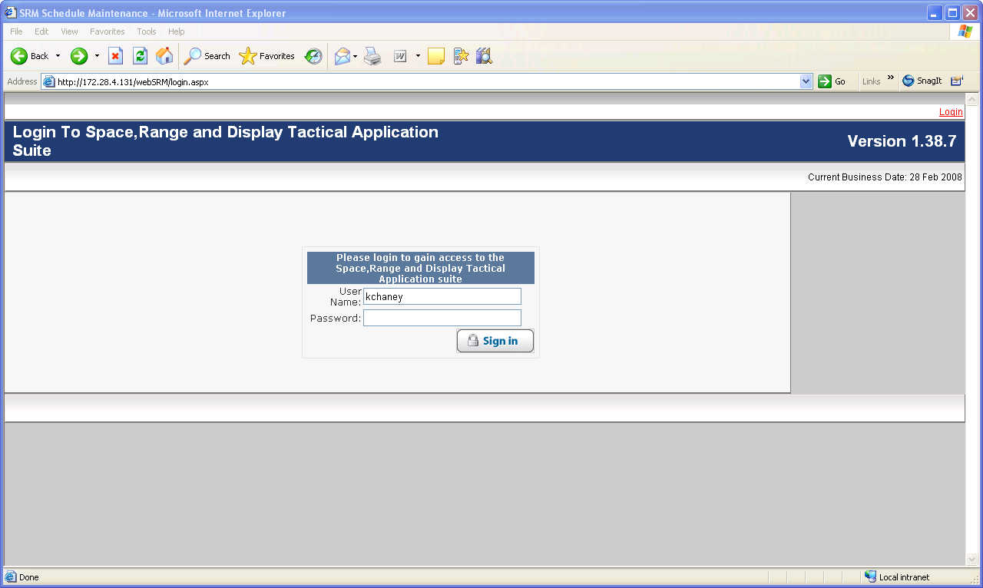

Access Supportive Plans Matrix

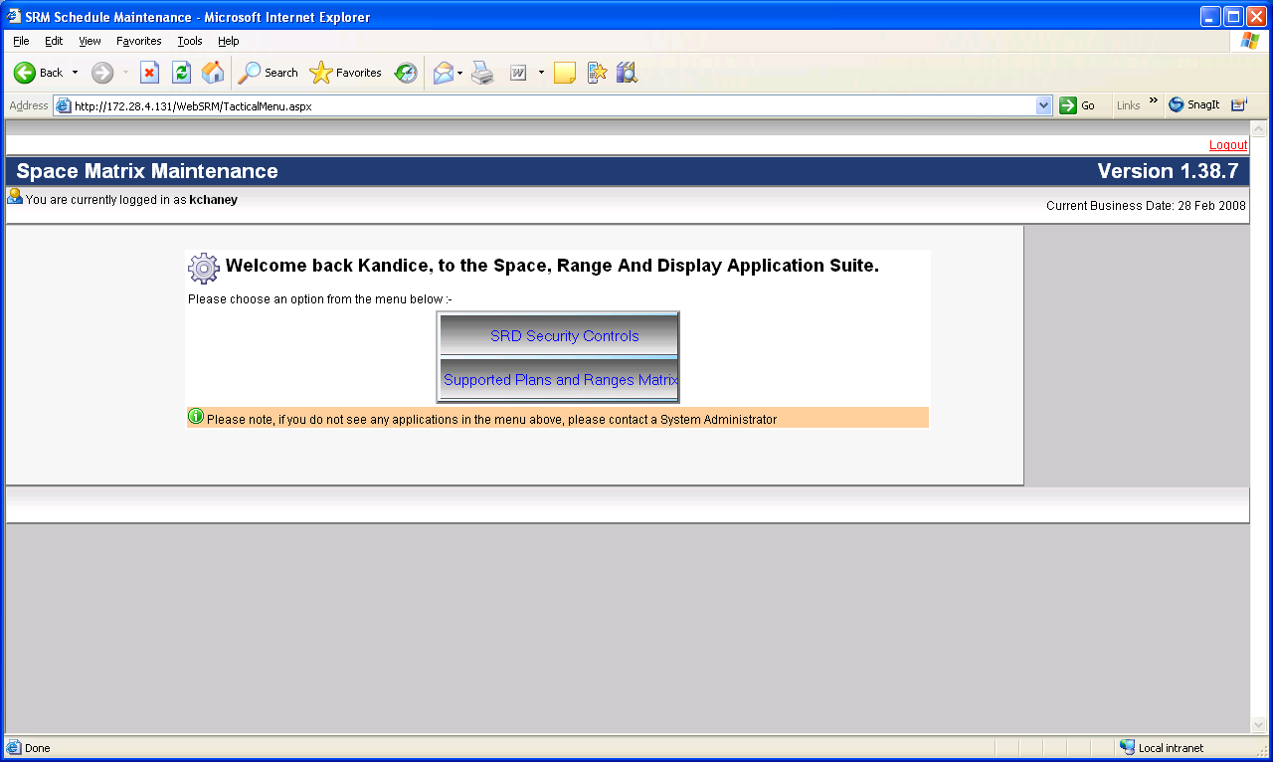
Select Supportive Plans and Matrix

We will search for the Range Event that we created: 247

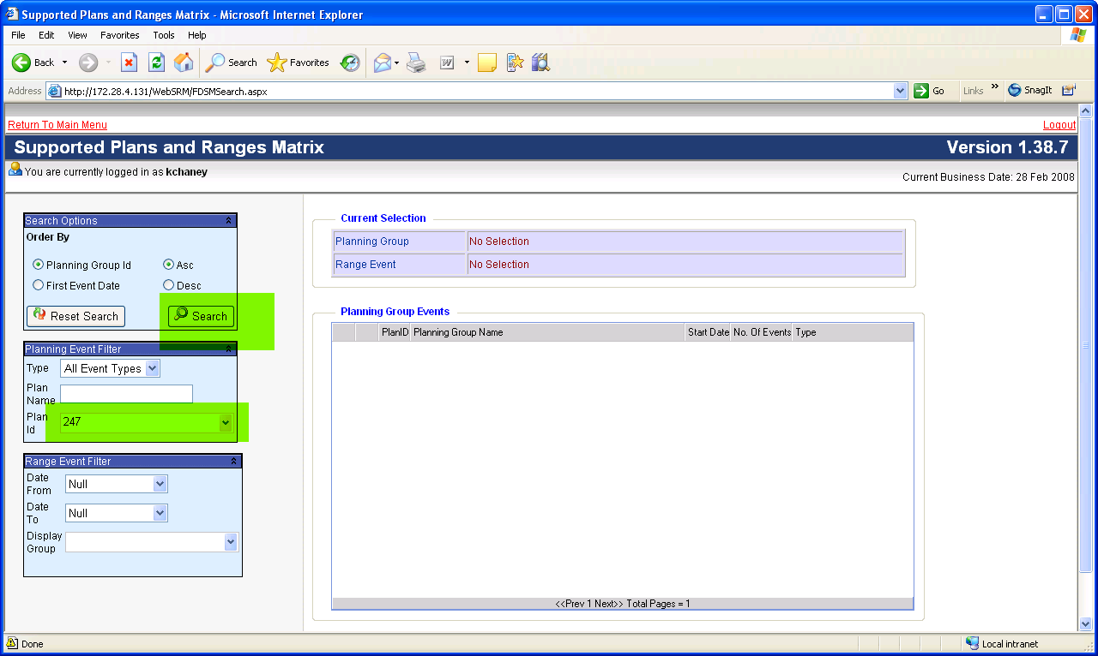

Enter the Planning event ID: 247
Click on “Search”

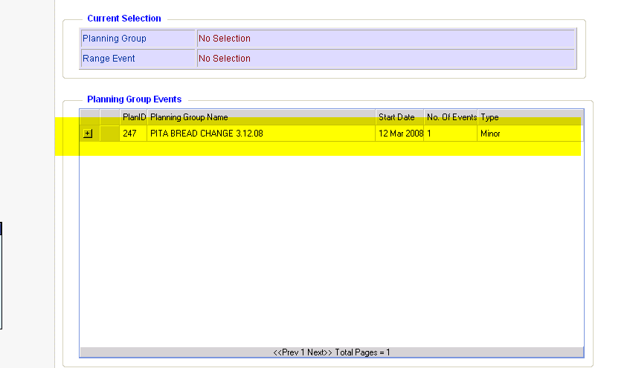

It will query your result

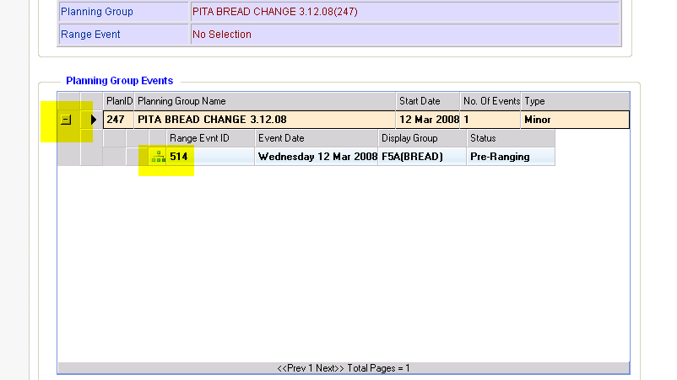

Click box to show the rest of the info, then click the icon after it.

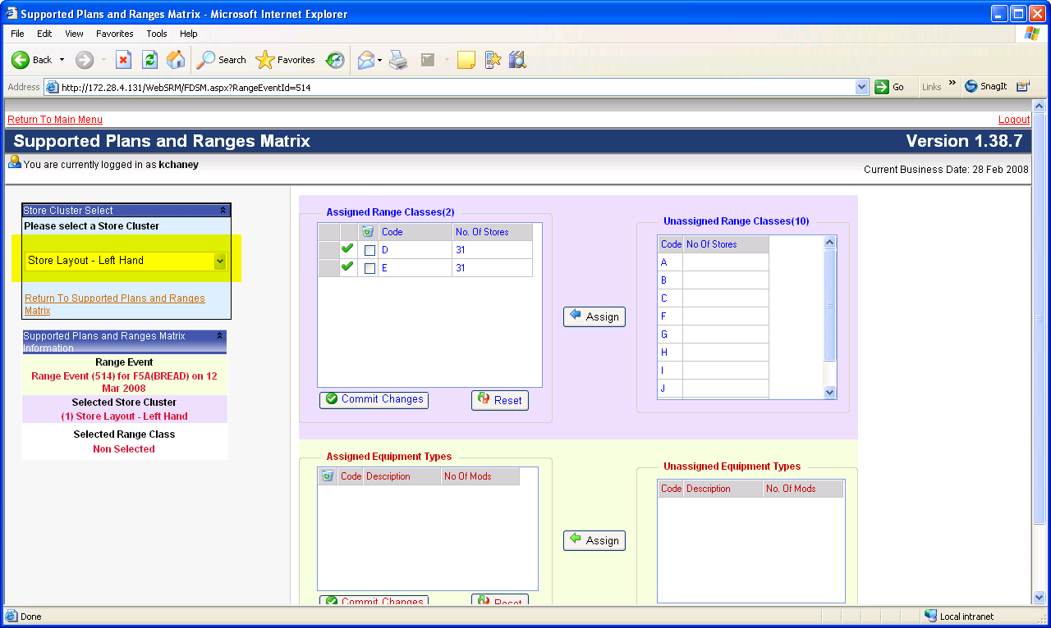

Click on Store Cluster drop down field, select the first cluster you’re going to work on

The rest of the fields will appear inside the boxes.

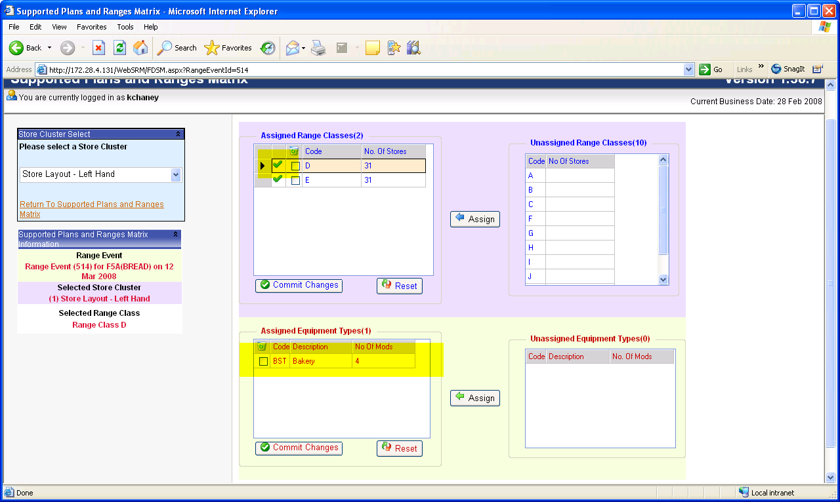

We’re just validating that the correct equipment type is assigned to the cluster.

Select the “check” (this could be slow) for D
The Assigned equipment will show up in the bottom box.
Select the “check” for E

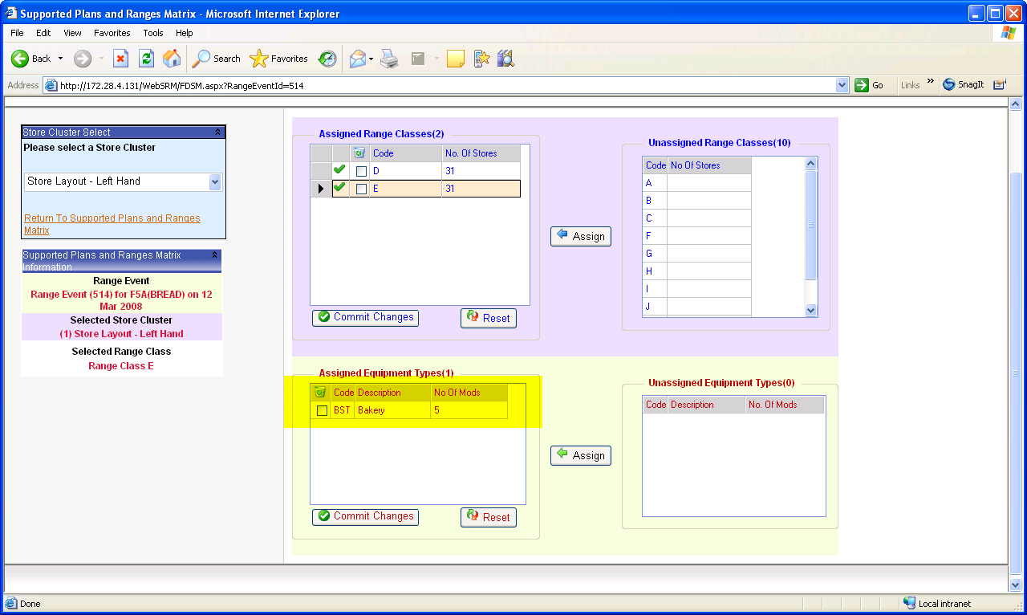

The “E” cluster will show the assigned equipment type

D has 4 Mods
E has 5 mods

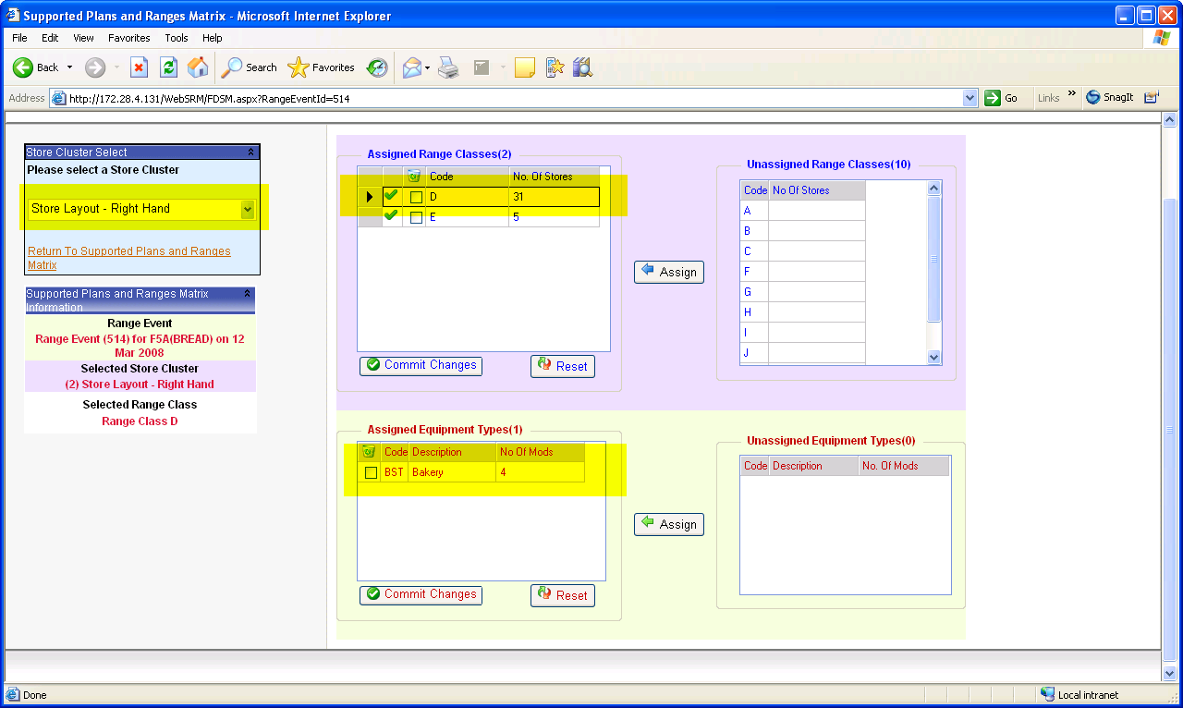

Now select “Store Layout – Right Hand”
Select Assigned Range “D”
Equipment type BST with 4 Mods will show up

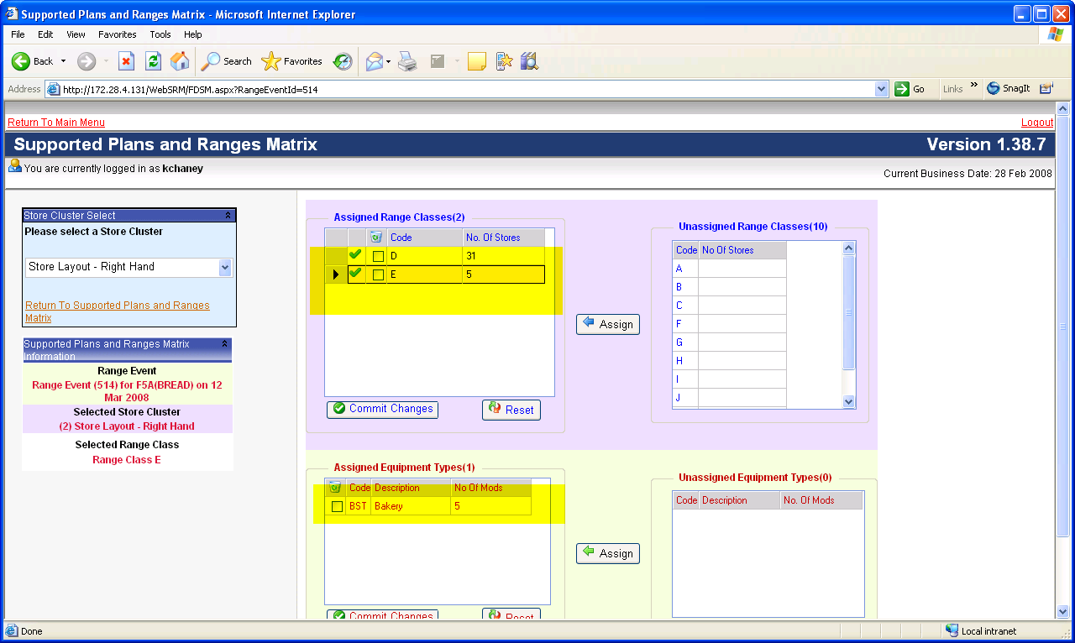

For Assigned Range “E”
It should have Assigned equipment ast BST with 5 mods

************* Chris to validate that No. OF Stores is reported properly ********

Go back to the main menu for supportive matrix plan

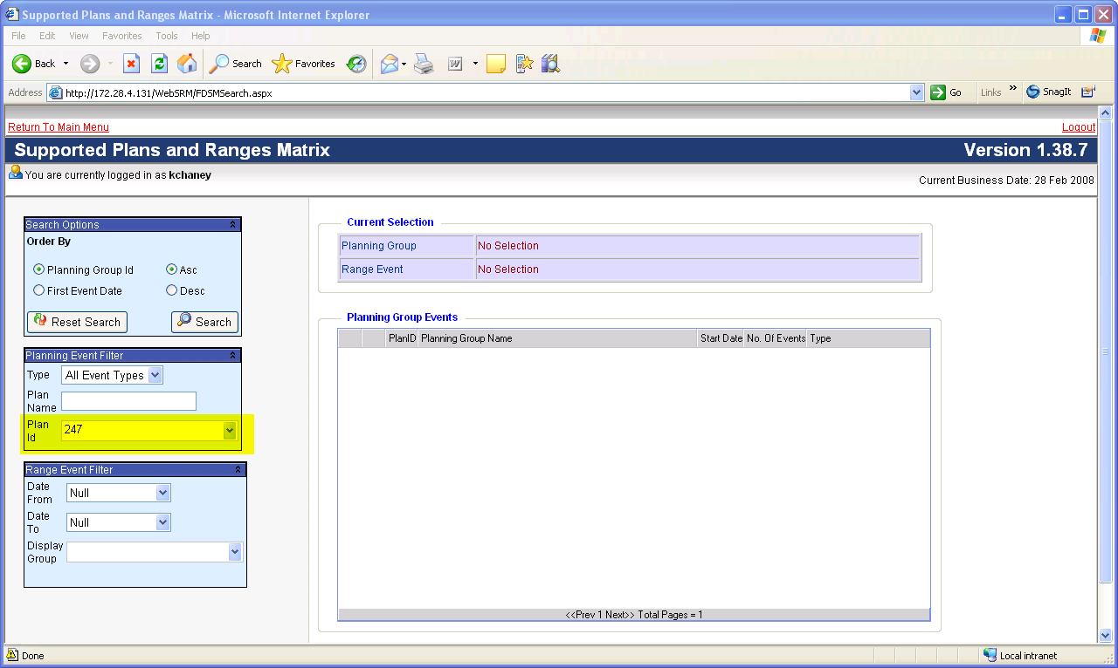

We will check and validate that the event we created is finalized in Supportive Matrix Plan system.

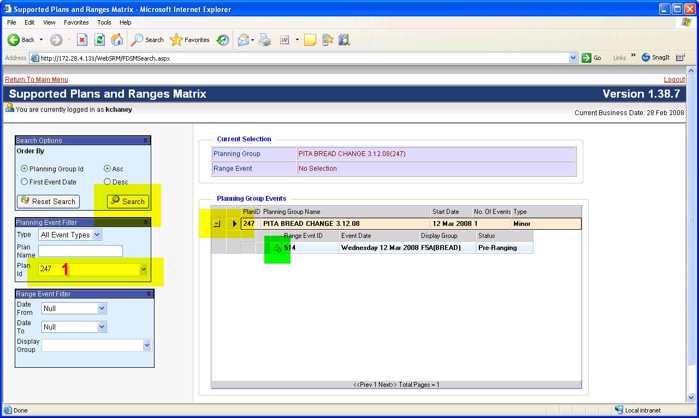

Enter the Planning Event ID 247
Click on Search button
The field on the right will be populated
Click on the + box
The Range Event ID will show up, there will be a little icon that will appear with an updated smaller icon. This usually means that your clustering has been confirmed with the system.

Log Off Suportive Matrix

Log back in to Ranging Controls

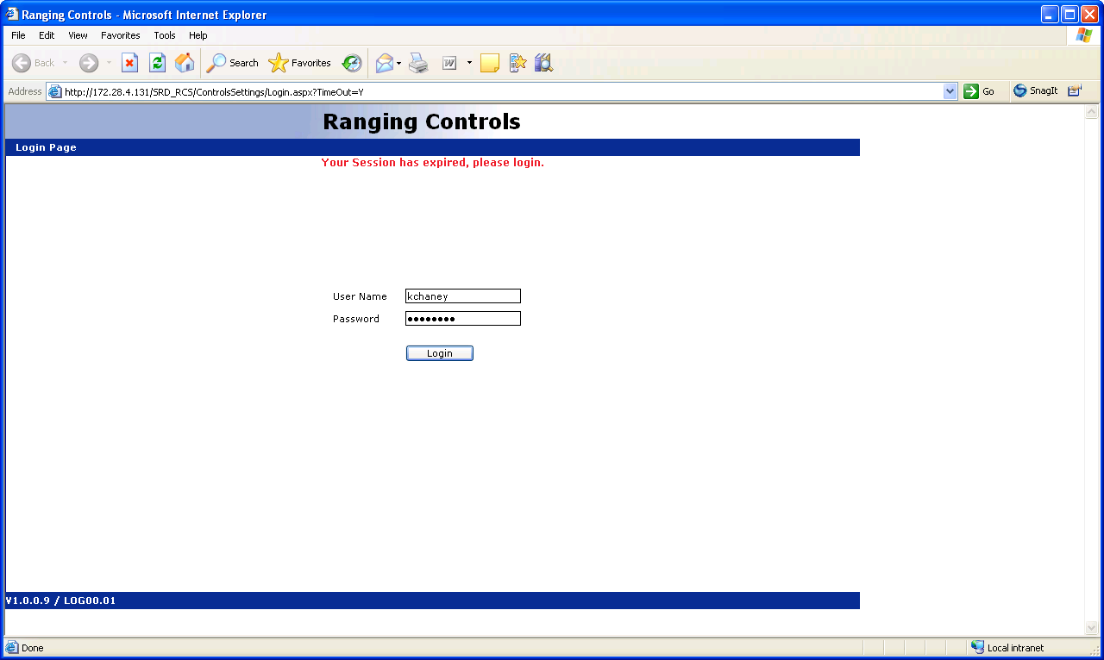

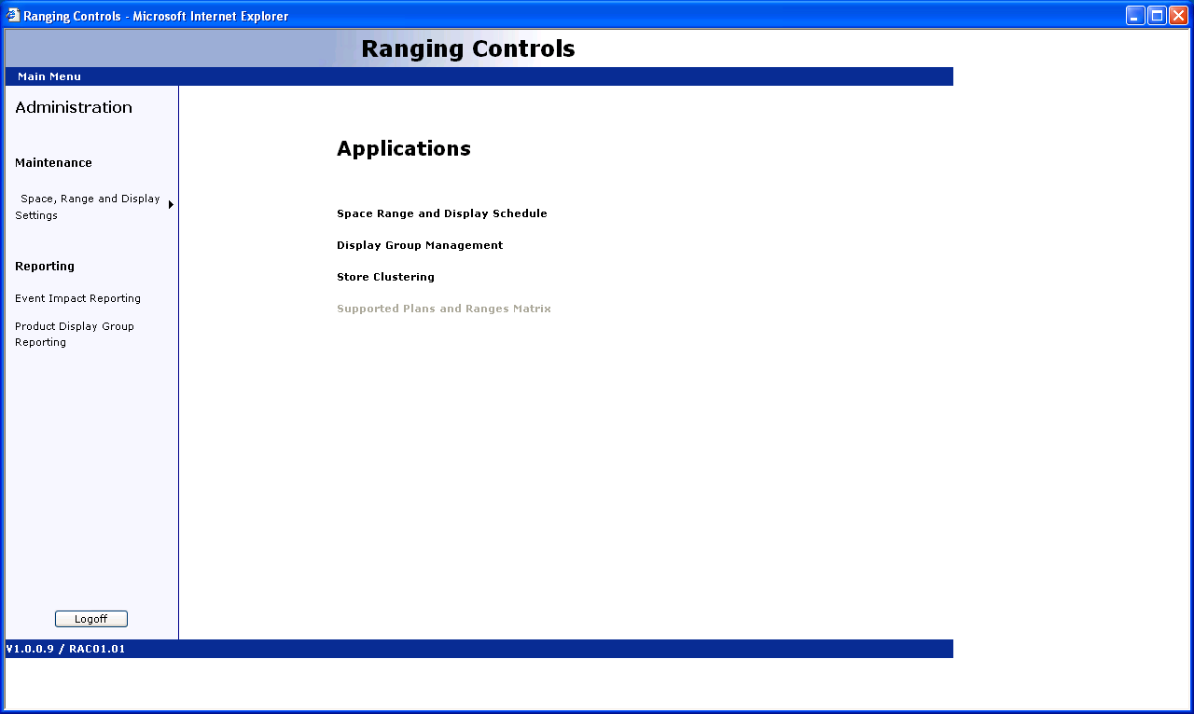

Select Space, Range and Display Schedule

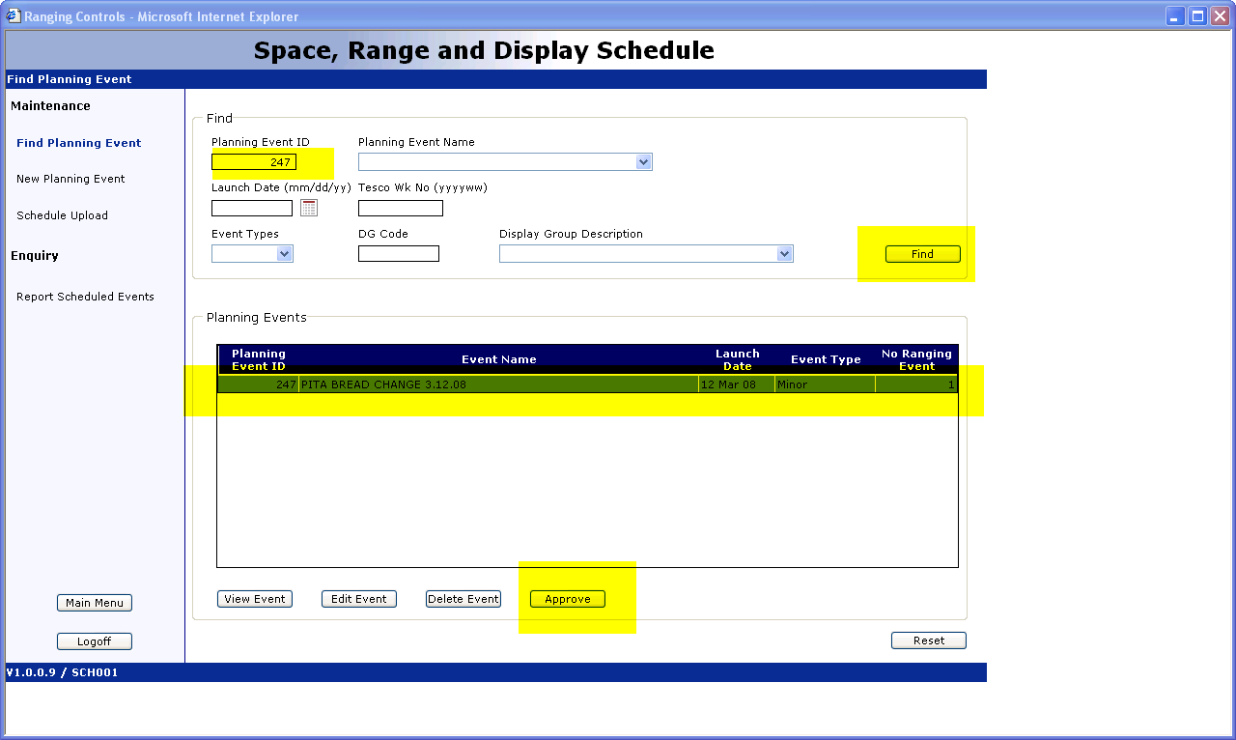

Enter Planning ID “247”
Click on “Find”
The Planning Event ID info 247 will appear
Click on “Approve”

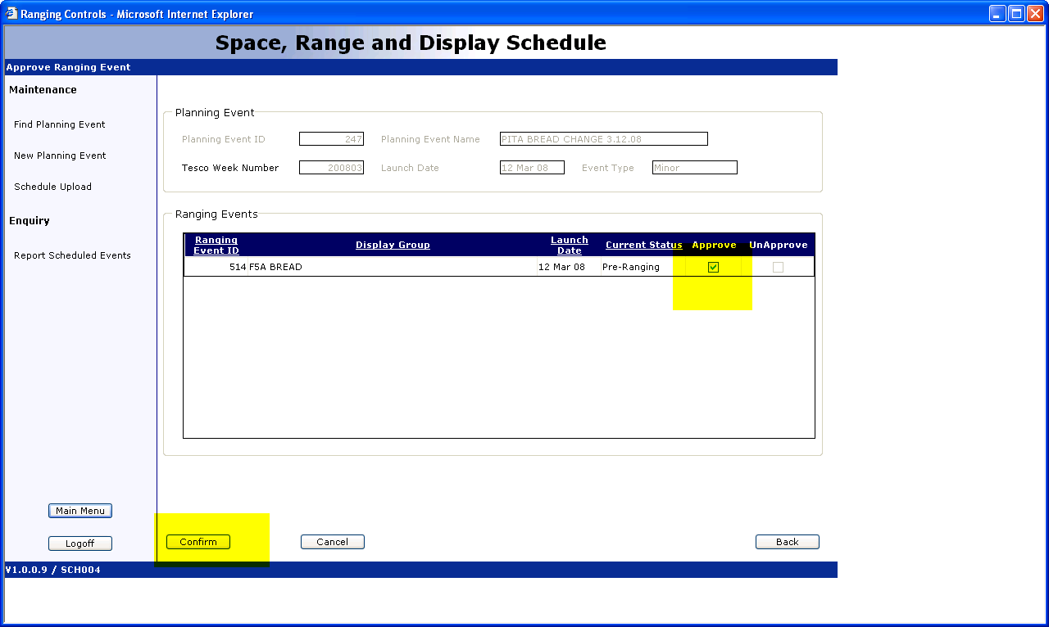

Check “Approve” check box
And then click on “Confirm”

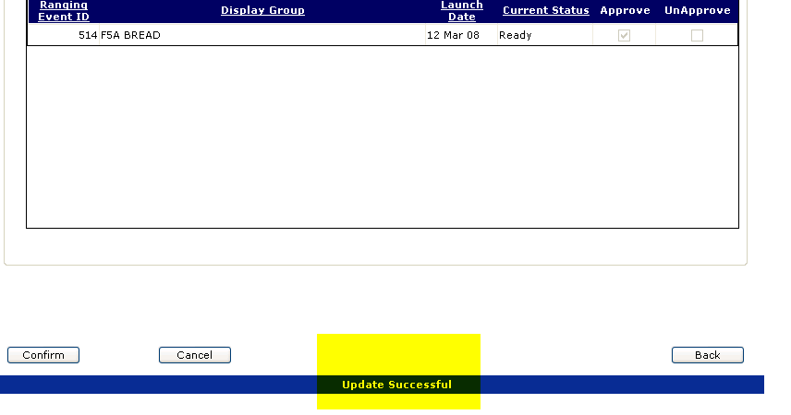

“Update Successful” will confirm that the Planning Event was created in the system

